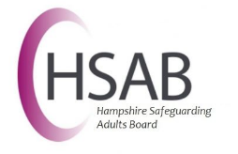
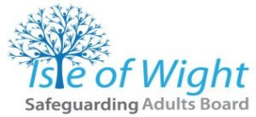
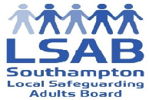
Meeting Notes
Date
Time
Location

This meeting was held under the umbrella of the 4LSAB Multi-Agency Risk Management Framework. This process has been endorsed by the partner agencies of all the Local Safeguarding Adults Boards in Hampshire, Isle of Wight, Portsmouth and Southampton and has been incorporated into each agency’s standard operating procedures. For more information, please refer to the 4LSAB Multi-Agency Risk Management Framework
All information shared at this meeting is confidential and privileged and is not to be shared outside of this meeting without the permission of the chair and the agency that provided the information.

Chair
Note taker
Host organisation

No. | Item | Action | Date
Present:

Apologies:

 | Current situation | Action | Date
Summary of any care and support offered or in place
Individual agency perspectives of the concerns
Risks to the individual and/or others
The individual’s views and wishes and how they wish to be involved
The individual’s strengths/assets (inc. family/wider social network)
 | Mental capacity
 | Consideration of the individual’s mental capacity around the areas of unmanaged risk
 | Assessment of risk
 | Collaborative and holistic assessment of presenting risks
 | Discussion
Legal powers and remedies in use or potentially available
Rationale for or for not using these
Lead coordinating professional for the process
Individual agency leads
Information sharing arrangements
Contingency and escalation plan
Any areas of unresolved disagreement
 | Shared risk management plan
Risk management plan
Confirm who will share the plan with the individual
How the individual will be involved and kept up to date
Monitoring and review arrangements

Please note this is not a verbatim record of the meeting, but a summary of information presented and discussed. Amendments will, therefore, only be circulated where the information recorded is factually incorrect, or where the meaning of what was actually said is substantially altered by the way it is recorded.

