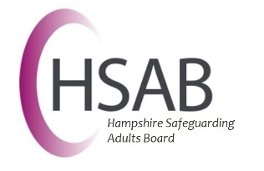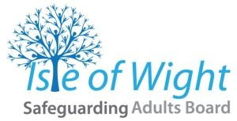

4LSAB Multi-Agency Guidance on Managing Allegations Against People in a Position of Trust

March 2026
Contents | Page
- Introduction | 3
- 4LSAB Allegations Management Guidance | 3
- When does this Guidance apply? | 4
- Responsibilities of commissioning organisations | 4
- Responsibilities of partner organisations | 4
- Responsibilities of local authorities | 5
- Applying this Framework in Practice | 5
- Information Sharing | 7
- Informing the person about whom the concerns have been raised | 7
- Informing the Employer | 7
- Working Jointly with the Police | 8
- Informing the Care Quality Commission | 8
- Informing Professional Bodies | 9
- Supervision and Training | 9
- Support for the person against whom allegation has been made | 9
- Recording and Data Collection | 10
- Appendix A: Referrals to Professional Bodies | 11
- Appendix B: Referrals to the Disclosure and Barring Service (DBS) | 12
- Appendix C: Flowchart | 15
- Appendix D: Examples | 16
- Appendix E: Risk Assessment Tool | 17

1. Introduction

Where concerns are raised about someone who works with adults with care and support needs, their employer or voluntary organisation must assess any potential risk to adults with care and support needs who use their services (or other services the person is connected with), and, if necessary, to take action to safeguard those adults.

All organisations should have clear policies reflecting the guidance within this document for dealing with allegations against people in positions of trust i.e. anyone working in either a paid or unpaid capacity, in any setting (including the person's own home), with adults with care and support needs. These policies should clearly distinguish between an allegation, a concern about the quality of care or practice or a complaint. This policy must have clear recording and information-sharing guidance and timescales for action and be mindful of the need to preserve evidence. This will be whether the allegation or concern is current or historical.

The guidance applies to all services, whether private, independent, or statutory that work with adults with care and support needs, regardless of who is funding their support or whether they are regulated by the Care Quality Commission (CQC) or not.

2. 4LSAB Allegations Management Guidance

In order to develop a consistent approach and to promote best practice across Hampshire, Portsmouth, Southampton and the Isle of Wight, the four Local Safeguarding Adults Boards have established a joint framework and process for how allegations against people in positions of trust should be responded to within their respective organisations.

The 4LSABs strongly encourage partner organisations to establish a nominated lead or Safeguarding Allegations Management Advisor (SAMA) to provide advice and guidance to their organisation and to maintain oversight of complex cases involving allegations against people in a position of trust.

The guidance is based on the following principles:

- It reflects a proportionate, fair and transparent approach and seeks to build on current internal allegations management processes rather than replacing these.
- It applies to anyone working in a position of trust such as employees, volunteers, or students, in a paid or unpaid capacity regardless of the sector.
- It deals with current as well as historical allegations.
- The sharing of information will be justifiable and proportionate based on an assessment of the potential or actual harm to adults or children at risk.

3. When does this guidance apply?

Where concerns amount to a safeguarding concern under the Care Act 2014, then the 4LSAB Safeguarding Concerns Guidance and Safeguarding Adults Multi-Agency Policy, Process and Guidance should be followed.

Where there are concerns in relation to transferable risks to other adults with care and support, then organisations should follow their own allegations policies and procedures.

This guidance relates to risks to adults with care and support needs. If there are risks to children or allegations including children, please refer to the Children's Partnership guidance. Children's legislation requires local authorities to have a Local Authority Designated Officer (LADO) to whom all concerns should be raised. There is no equivalent role for adults within the law that does the same job as the LADO. Therefore it is the responsibility of organisations to manage allegations against people in a position of trust who work with adults. If the member of staff works with both adults and children, both processes need to be followed.

4. Responsibilities of commissioning organisations

Commissioning organisations should build reporting requirements into their existing procurement, commissioning and contract arrangements to ensure that provider organisations promptly share information about incidents falling within the remit of this Guidance with their commissioners.

5. Responsibilities of partner organisations

Individual organisations are responsible for responding to allegations regarding any person working for them in a position of trust with adults with care and support needs and for undertaking all necessary action in line with their internal process, including HR, and agreed timescales. The specific responsibilities of individual organisations include:

- Establishing a clear internal allegations management procedure setting out the process, including timescales, for investigation and what support and advice will be available to individuals against whom allegations have been made. This procedure should reflect the 4LSAB Multi-Agency Guidance on Managing Allegations Against People in a Position of Trust.
- Ensuring their staff and managers have access to expert advice and guidance to enable them to fulfil their responsibilities when responding to allegations.
- Responding promptly to allegations regarding their staff and for undertaking all necessary action in line with their internal process and agreed timescales.
- Monitoring the progress of cases to ensure that they are dealt with as quickly as possible, consistent with a thorough and fair process.
- Ensuring appropriate systems are in place to support and provide regular updates to the employee in respect of the investigation.
- Making prompt referrals to the Disclosure and Barring Service (DBS) and/or Professional Registration Bodies, as relevant.
- Ensuring appropriate recording systems are in place and that these provide a clear audit trail about the decision-making process and any recommendations arising from the investigation and subsequent actions.
- Ensuring the control of information in respect of individual cases is in accordance with accepted data protection and confidentiality requirements.
- Maintain records of the number and nature of allegations made and using this data to inform service improvement and development.
- If there is a possibility that a crime has been committed, liaise with the Police.

Risk management arrangements are the responsibility of the employing organisation taking into account their assessment of the risk, their own internal policies and procedures, and employment law.

6. Responsibilities of local authorities

Local authorities should ensure that their safeguarding information and advice services are clear about the responsibilities of employers, student bodies and voluntary organisations, in such cases, and signpost them to their own procedures and legal advice appropriately. Information and advice services should also be equipped to advise on appropriate information sharing and the duty to cooperate under Section 6 of the Care Act.

Local authorities should ensure that there are appropriate arrangements in place to effectively liaise with the police and other agencies to monitor the progress of cases and ensure that they are dealt with as quickly as possible, consistent with a thorough and fair process.

7. Applying this Framework in practice

- As soon as a member of staff becomes aware of an allegation of harm, abuse, or neglect (including self-neglect) against a person in a position of trust, they should then determine whether any adults who have been harmed have care and support needs.
- If a ‘person in a position of trust’ is alleged to have abused or harmed an adult with care and support needs, or presents a likely risk, it is essential that the concerns are appropriately reported using the 4LSAB Multi-Agency Safeguarding Adults Policy and Guidance (July 2023)

If the concern meets the criteria for a section 42 enquiry, the local authority will be the lead agency for the section 42 enquiry. The employing organisation's SAMA and HR retains the responsibility for mitigating the risks in relation to the person there has been an allegation against.

If there is no named adult with care and support needs who has experienced (or is at risk of) abuse or neglect, consider if there may be a transferable risk to other adults with care and support needs or children.

Examples of transferable concerns could include allegations that relate to a person who works with adults with care and support needs who has:

- Behaved in a way that has harmed, or may have harmed an adult or child.
- Committed a criminal offence against, or related to, an adult or child.
- Behaved towards an adult or child in a way that indicates they may pose a risk of harm to adults with care and support needs.

Concerns could also arise from the person’s home / personal life, as well as within their work.

There may be occasions when an adult’s behaviour, either within the workplace or the adult’s personal life, gives rise to concerns about whether they might pose a risk if they work with children or adults. The employer, in conjunction with other appropriate agencies, may need to make a judgement about the possible impact of that behaviour upon the children or adults they come into contact with in their role. What constitutes a risk will vary depending upon the context and nature of the work the individual is involved in.

What action should be taken if a transferable risk is identified?

The responsible manager in the organisation should:
- consider any immediate risk and act accordingly
- liaise with HR and consider requirements and standards covered in any policies and procedures (eg conduct policies)
- document any concerns
- consider if the police need to be informed (eg if a crime has taken place)
- involve any other relevant parties eg CQC

Where a formal safeguarding enquiry is not being undertaken, agencies should follow their internal process and work with HR to take any appropriate action.

Risk management arrangements are the responsibility of the employing organisation taking into account their assessment of the risk, their own internal policies and procedures, and employment law.

Disclosure and Barring Service (DBS)

Employers and volunteer managers of people working in ‘regulated activity’ have a legal duty to make referrals to the Disclosure and Barring Service in certain circumstances. If the legal duty to refer is not met then a referral can still be made to DBS in the interest of safeguarding adults and children.
If the legal duty to refer does exist then that duty to refer to DBS exists even if a referral has been made to Police, Local Authority or a regulatory body.

For more information on what constitutes 'regulated activity' with adults see here. For more information on referrals to the Disclosure and Barring Service see Appendix B.

8. Information Sharing

Decisions on sharing information must be justifiable, proportionate and based on the potential or actual harm to adults or children at risk. The rationale for decision-making must always be recorded. When sharing information between agencies about adults at risk it must only be shared:

- Where relevant and necessary, not simply sharing all the information held;
- With the relevant people who need all or some of the information; and
- When there is a specific need for the information to be shared at that time.

In deciding whether the information should be shared, it is necessary to consider the key question of whether the person has behaved (or may have behaved) in a way that means their suitability to undertake their current role or to provide a service to adults with care and support needs should be reviewed.

There may be times when a person is employed to work with adults but their behaviour towards a child or children (for example outside of work) may impact on their suitability to work with or continue to work with adults. There may also be times when a person’s conduct towards an adult outside of work (eg domestic abuse) may impact on their suitability to work with or continue to work with adults with care and support needs. All these situations must be risk assessed individually in order to make a decision about referring the case to the relevant organisation.

Further guidance can be found in the 4LSAB Multi-agency Guidance on Information Sharing.

9. Informing the person about whom concerns have been raised

Unless it puts the adult at risk or a child in danger, the employer of the person should inform them that an allegation against them has been made. They should be offered a right to reply.

10. Informing the employer

- If an organisation becomes aware that there is a risk to adults with care and support needs from a person who is employed to provide care and support, then it is important that that organisation makes their employer aware.
- The local authority do not need to be aware or informed of this unless the person is employed by the local authority or a safeguarding concern needs to be raised for an individual adult.
- If concerns arise in the person’s personal life, or in another work setting, the decision to share information must be justifiable and proportionate and based on the potential or actual harm to adults with care and support needs. The decision to share information and the rationale for doing so should be recorded.
- The following issues should be taken into consideration when making decisions about sharing information with the employer:

  - Nature and seriousness of the actions/behaviour.
  - The context within which the actions/behaviour occurred.
  - Patterns of actions/behaviour.
  - Nature of the person’s access/role with adults at risk.
  - Potential impact on an adult with care and support needs.

- The organisation should check appropriate information has been shared with the employer to enable them to assess risk, and review the suitability of the person continuing to work and any other actions required.
- In accordance with local arrangements, if the person works for the NHS, the ICB Safeguarding Lead must be informed.
- If the person works for the Police, the Police Safeguarding Lead must be informed.

11. Working jointly with the Police
- If the concerns involve possible criminal offences to either an adult or child, liaise with the Police about the need for possible criminal investigation.

- When the Police are undertaking criminal investigations, they have a common law power to disclose sensitive personal information to relevant parties where there is an urgent ‘pressing social need’.

- A pressing social need might be the safeguarding or protection from harm of an individual, a group of individuals, or society at large. This could include informing a relevant employer about criminal investigations relating to their employee where this has been assessed as necessary and appropriate in a particular case.

12. Informing the Care Quality Commission (CQC)
- If the person is employed or volunteers for a regulated service provider, CQC should be informed by the employer.

- CQC can take action as deemed appropriate within their own procedures to ensure the service has appropriate standards of practice to prevent and respond to any future risks of harm.

- This includes the employer’s ‘fitness’ to operate and responsibility to safeguard adults at risk.

13. Informing Professional Bodies

- If the person is registered with a Professional Body and there are concerns about their fitness to practice, the employer/volunteer manager must refer to the professional body’s published guidance and consider the need to raise the concern with that Professional Body.

- A Professional Body has a range of options where appropriate, these usually include suspending the person from practice, de-registering them or imposing conditions of practice that the person must work under. See Appendix A for more information about referrals to Professional Bodies.

14. Supervision and Training

- Supervision and training may be relevant to managing aspects of a presenting risk.

- Supervision is a formal process ensuring the performance of each member of staff in a team, section, or unit is evaluated and reviewed so that, where necessary, learning and change can take place. Supervision is an important vehicle for meeting practice standards.

- Supervision should address any issues of practice that are below the expected standard; and be used to ensure the practice of employees and volunteers reflects essential values and principles of practice, including choice, capacity, consent, privacy, dignity and respect to patients/service users, as well as the promoting safeguarding and individual wellbeing.

- Training should be used to ensure employees, students and volunteers have the appropriate skills, knowledge and attitudes; but also in response to identified needs as may emerge from practice, supervision or personal development programmes.

15. Support for the person against whom allegation has been made

Alongside the duty of care towards the adult at risk, there is also a duty of care to the employee. The employer needs to provide support to minimise stress associated with the process. This may need to include:

- Support to understand the procedures being followed
- Updates on developments
- Opportunity to respond to allegations/concerns
- Support to raise questions or concerns about their circumstances.
- Make any onward referrals to support services as required (eg. substance use support)

There may be limitations on the amount of information that can be shared at a particular time in order not to prejudice any enquiry/investigation or place any person at risk. Support may be available via Occupational Health or employee welfare arrangements where they exist. If the person is a member of a union or professional association or network, they should be advised that they may wish to seek support from that organisation.

The person may also wish to seek independent advice regarding employment issues. Such advice and support, however, should be supplementary to that provided by the employer. There may be occasions where there is a need to agree changes to the person’s working arrangements or to the support provided, to safeguard them from unfounded allegations in the future.

16. Recording and data collection

Individual organisations should also establish monitoring arrangements to enable activity relating to allegations against staff to be tracked. Collated anonymised information about the number and nature of allegations made and their outcomes should be produced at least annually, and these reports shared with relevant boards, committees and leadership teams to inform service improvement and development.

Appendix A: Referrals to Professional Bodies

If the person is registered with a Professional Body and there are concerns about their fitness to practice, the employer/volunteer manager must refer to the Professional Body’s published guidance and consider the need to raise the concern with that professional body.

A Professional Body has a range of options where appropriate, these usually include suspending the person from practice, de-registering them or imposing conditions of practice that the person must work under.

Each Professional Registration Body:

- Maintains a public register of qualified workers
- Sets standards for conduct, performance and ethics
- Considers allegations of misconduct, lack of competence or unfitness to practice
- Makes decisions as to whether a registered worker can practice

Notification to a Professional Body is the responsibility of the employer. Where this action has been agreed with the organisation’s nominated Safeguarding Lead, confirmation should be provided to them that the action has been completed. As the responsible authority for adult safeguarding, the Local Authority has the power to make a referral where the relevant criteria have been met and should do so where it is necessary to ensure an appropriate referral has been made. Other agencies can make a referral if they are more appropriately placed to do so, however the Local Authority must be assured that a referral has been made.

Appendix B: Referrals to the Disclosure and Barring Service (DBS)

The DBS service protects the public by helping employers make safer recruitment and employment decisions and by Barring individuals who pose a risk to vulnerable groups from working in certain roles.

The Disclosure and Barring Service can bar a person who has harmed or is a future risk of harm to vulnerable people, including children, from engaging in regulated activity in the future. If a person is barred it becomes an offence for a person to permit an individual that they know or have reason to believe is barred to work with the vulnerable group that they barred from. It is also an offence for a person who is barred to seek, offer or engage in regulated activity with the vulnerable group that they are barred from.

Employers and volunteer managers of people working in ‘regulated activity’ have a legal duty to make referrals to the Disclosure and Barring Service in certain circumstances. The Local Authority also has a power to make a referral and should do where it is necessary to ensure the appropriate referral has been made. Regulated activity is work (both paid and unpaid) with children or vulnerable adults that meets certain criteria. In relation to vulnerable adults, regulated activity in broad terms includes activities involved in:

- Providing health care (by or under the supervision of a healthcare professional)
- Providing personal care (washing and dressing, eating, drinking and toileting, care of the skin, hair or nails for health reasons only)
- Providing social work (provided by a social care worker to an adult who is a client or potential client)
- Providing assistance with the financial day to day running of the adult’s own household by managing their cash, paying bills or shopping
- Providing assistance in the conduct of personal affairs (Power of Attorney, deputies appointed under Mental Health Orders)
- Conveying the person (Must be for health, personal or social care due to age, illness or disability)

More on regulated activity with adults can be found on the DBS website- Regulated activity with adults in England and Wales - GOV.UK

Types of Barring referral:

There are three ways in which DBS can receive a Barring referral. Barring referrals from Employers, Voluntary organisations, Agencies, Keepers of Register and Supervisory authorities are called Discretionary Referrals. Discretionary referrals can be submitted by anybody at any time. DBS are legally required to view all and any information received.
Where a Discretionary referral is received, and DBS are minded to add the person to a Barred List the referred person will be invited to make representations before the DBS makes a decision.

DBS will only add a person to a Barred List if it is the appropriate and proportionate thing to do.

There is a legal duty placed on regulated activity providers and personnel suppliers to make a DBS referral in circumstances where they have permanently removed a person from regulated activity with adults or children through dismissal or redeployment (or would have if the person had not left, resigned, retired or been made redundant); because the person has:

  - Been cautioned or convicted for a relevant offence; or
  - Engaged in relevant conduct in relation to children and/or vulnerable adults [i.e. an action or inaction (neglect) that has harmed a child or vulnerable adult or put them at risk of harm]; or
  - Satisfied the Harm Test in relation to children and/or vulnerable adults [i.e. there isn’t sufficient evidence of relevant conduct but a risk of harm to a child or vulnerable adult still exists].

More on what would be considered as relevant conduct or the Harm test can be found on the DBS website at - Making barring referrals to DBS - GOV.UK.

It is also possible to make a referral where this legal duty has not been met. For example, where there are strong concerns, but the evidence is not sufficient to justify dismissing or removing the person from working with children or vulnerable adults. Such a referral would need to be compliant with relevant employment and data protection laws.

Where the need for a referral to the Disclosure and Barring Service (DBS) has been agreed with the organisation’s nominated Safeguarding Lead, confirmation should be provided to them that the action has been completed. As the responsible authority for adult safeguarding, the Local Authority has the power to make a referral where the ‘person in a position of trust’ is employed in another organisation, and should do so where it is necessary to ensure an appropriate referral has been made. The legal duty to refer will still exist for the Regulated Activity Provider or Personnel Supplier.

What does a good quality referral to DBS look like?

- Timely - balance the need for a swift response with a need for sufficient documentary/supporting evidence
- Accurate and fully completed referral form - recognition of any gaps, if present
- Chronology - detail the sequence of events from initial notification to the final outcome
- Relevant information - To facilitate the DBS decision making process
- Victim impact – What was the impact on the victim
- Training and supervision records - accurate, dated training and supervision records
- Internal and external investigative and disciplinary processes - including interviews, police intervention and/or multi-agency meetings. NB include recruitment and additional employment information i.e. any previous misconduct or complaint

The quickest and easiest way to submit a barring referral to DBS is to use the online Barring Referral Service on the DBS website. A link to the service is provided here- Barring Referral Service - GOV.UK.

The full up-to-date guidance and definitions must be referred to when deciding whether to make a Disclosure and Barring Service referral. For further information contact the Disclosure and Barring Service Regional Outreach team. You can find your Adviser's contact details on the DBS website at The DBS Regional Outreach service - GOV.UK.

Appendix C: Flowchart

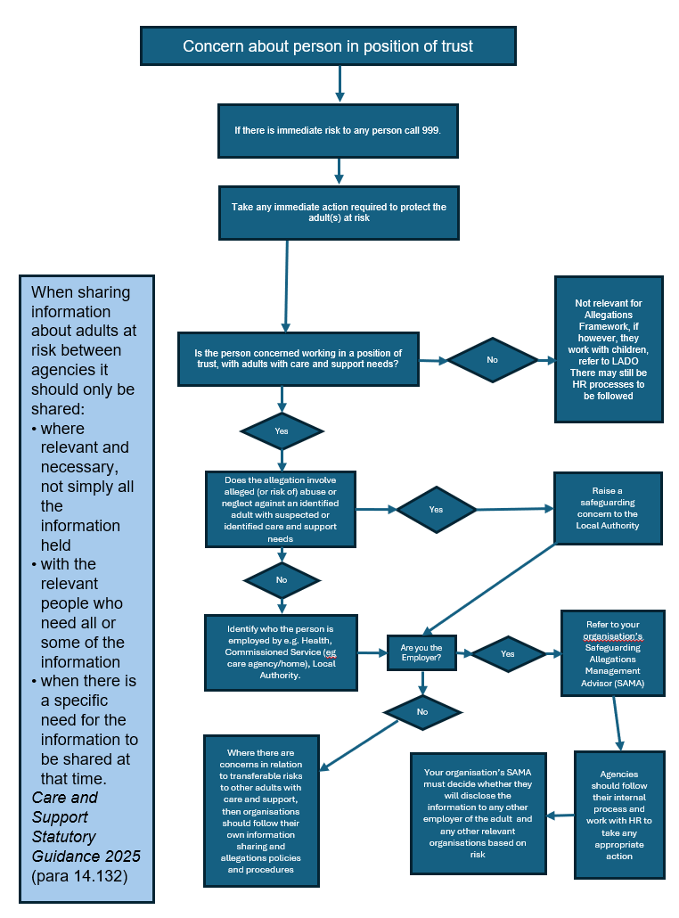

Appendix D: PiPOT Examples
Non-reportable | Requires consultation | Reportable
These are concerns that do not indicate harm or risk of harm to adults with care and support needs and do not suggest a transferable risk.  They are usually low-level issues that can be managed internally through supervision, training, or HR processes. | Concerns that are ambiguous or borderline and raise questions about potential risk or suitability.  These may involve patterns of behaviour, boundary issues, or emerging indicators that could become serious if not addressed. | Concerns that clearly indicate harm, abuse, neglect, or criminal behaviour, or show that the person may pose a risk to adults with care and support needs, even if the incident occurred outside work.
Examples:  - Quality of care issue or complaints that do not involve harm or risk of harm  - Performance or conduct issues that do not pose a risk to adults with care and support needs  - Historic allegations where risk assessment shows no current or transferable risk  - Training needs identified through routine review, not linked to harm or risk | Examples:  - Patterns of poor practice that could escalate into harm  - Behaviour suggests risk to others but no named adult harmed  - Inappropriate comments and/or boundary issues but no clear harm  - Financial irregularities suspected | Examples:  - Allegation of harm, abuse or neglect by a person in a position of trust towards an adult with care and support needs  - Criminal offence committed against an adult by the person in a position of trust  - Behaviour indicating a likely risk of harm to an adult with care and support needs  - Duty to refer to CQC, DBS or Professional Body following dismissal or removal from regulated activity due to harm or risk of harm
Action:  - Follow internal policies and procedures.  - Record the concern and actions taken.  - Monitor for patterns, multiple low-level concerns could escalate. | Action:  - Discuss internally with safeguarding lead or SAMA.  - Monitor for patterns  - Document decision-making and rationale. | Action:  - Refer to SAMA immediately.  - Complete safeguarding referral to Local Authority.  - Notify police if a crime is suspected.  - Consider DBS and referral to professional/regulatory body (e.g. CQC, RCOT, RCN etc)
If you have identified an issue that needs referring to the relevant SAMA, this does not replace your responsibility to raise a safeguarding concern to the local authority. For further information see the 4LSAB Safeguarding Concerns Guidance

Appendix E: Example Risk Assessment

Name of Staff member ________________________________
Team / Service
Directorate |  | Proposed Review date
Role

Background to Concern:

Area of concern | Who might be harmed and how? | Precautions already taken (What are you already doing – existing control measures)? | Are additional control measures necessary, and what are they? | Action owner and required completion date | Date completed
Including type of abuse/neglect

Other Actions taken in relation to this concern:
Eg. Onward referral and outcome

Risk Assessor | Signature | Date
Responsible Manager | Signature | Date
Staff member | Signature | Date

Reviewed by: | Review date: | Any additional control measures or actions taken:

