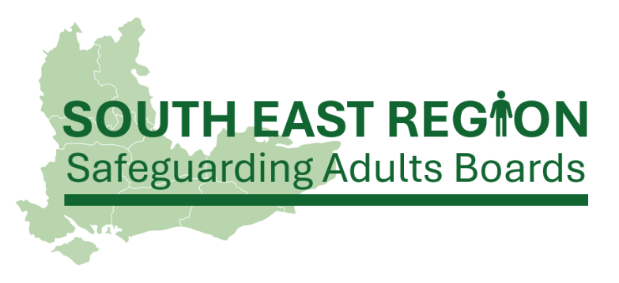
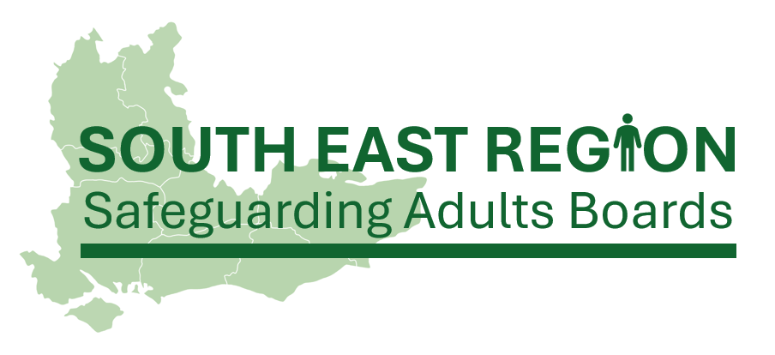
Version 1 | November 2025

South East region framework for cross-boundary Safeguarding Adults Reviews
This framework has been produced with reference to the Cross-Boundary Safeguarding Adults Reviews: Guidance for Safeguarding Adults Board Business Units (North East SAR Champions, 2025).

Introduction
The Care Act 2014 states that Safeguarding Adults Boards have a statutory responsibility to arrange a Safeguarding Adults Review when an adult dies, or experiences serious harm, as a result of abuse or neglect (whether known or suspected), and where there is concern that partner agencies could have worked more effectively together to protect the adult.
The Care Act 2014 also states that the Safeguarding Adults Board responsible for commissioning and leading on the Safeguarding Adults Review has been the Board in the geographical location of where the abuse or neglect occurred (we will refer to this Board hereafter as the ‘host’ Board). However, there is a growing recognition that the host Board may not be the best placed to assume this responsibility.
In many cases where an adult moves across geographical boundaries, either on a temporary or permanent basis, agencies within the locality of the host Board may have had limited to no involvement with the adult. Where this is the case, the host Board can find themselves either limited in their access to learning, or coordinating a review with agencies who sit outside of their locality and are therefore unknown to them.
The area where an individual died or experienced abuse or neglect may not be the same as their area of ordinary residence, meaning they might not be known to local agencies. In these situations, it is essential that relevant Boards work together to share proportionate information so that informed decisions can be made about whether there is ‘reasonable cause for concern about how the SAB, its members, or other relevant parties worked together to safeguard the adult.’ Without this information, most out-of-area SAR referrals are unlikely to meet the criteria.

What is the objective of this framework?
The objective of this framework is to put in place an agreed best practice framework for Safeguarding Adults Boards across the South East region, outlining the process for Safeguarding Adults Reviews where:
- the adult is of no fixed abode, or travels regularly across local authority boundaries;
- the location of the abuse or neglect is different to that of where the adult is ordinarily resident;
- the location of death is different to that of where the adult is ordinarily resident and/or the location of the abuse or neglect; this is particularly relevant in the case of suicide hotspots where the adult may have travelled with the express intent of taking their own life.

Key considerations
This framework is written with the recognition that each Safeguarding Adults Board will have their own guidance, policies, and procedures to adhere to. It is important that Boards ensure that they are operating within their own area guidance, policies, and procedures alongside this best-practice framework, particularly in relation to:
- Safeguarding Adults Review protocols
- Information-sharing protocols
- Multi-agency working guidance
- Communication and engagement strategies

The framework
In this section you will find a best-practice framework for managing Safeguarding Adults Reviews where there has been involvement by agencies in more than one local authority area, either prior to, or at the point of, the death or serious harm of the adult.


Step 1: Receipt of a referral
Upon receipt of a Safeguarding Adults Review referral, the host Board should triage the referral, and identify whether there needs to be involvement from any other Board(s). The Board Manager should initiate contact with the other Board(s) to discuss their involvement, and to agree which Board will lead on consideration of the referral, and any resulting Review (we will refer to this Board hereafter as the ‘lead’ Board).

Step 2: Initial discussion
The relevant Board Managers should meet (in-person or virtually) to discuss the following:
- Confirm where the adult was ordinarily resident;
- Confirm where the abuse or neglect took place;
- Confirm the location of death or serious injury;
- Confirm which agencies were involved with the adult, and in which local authority area they are based;
- Agree which local authority area is likely to have access to information that will identify learning;
- Agree which Board will lead on consideration of the referral, and any resulting Review.
Ensure that the reasons for all decisions are clearly recorded and shared with all involved Board Managers for their records.
If, during the course of this initial discussion, the involved Board Managers are not able to come to a consensus on who the lead Board will be, the referral should be escalated to the relevant Independent Chairs.
The Independent Chairs should refer to the above discussion points and, if needed, can request that the host Board gather additional information from involved agencies to support their decision-making. In cases where additional information-gathering takes place, involved Board Managers must support the host Board to liaise with involved agencies from their areas.
If, after this process, the Independent Chairs are unable to come to an agreement, the involved Independent Chair/s may consider consulting with the Co-Chairs of the SE Region Group to gain a second opinion and discuss potential options to resolve. Where the Director of Adult Social Services (DASS) also holds the position of Independent Safeguarding Adults Board Chair, local Safeguarding Adults Review policies and procedures should reference alternative escalation pathways.

Step 3: Assessing the referral against the criteria
Once the lead Board has been agreed, they should progress with their usual process for assessing the referral against the criteria for Safeguarding Adults Reviews. This is likely to be through a Safeguarding Adults Review subgroup or panel. Representatives from the other involved Boards must be invited to attend and to be a part of this decision-making process, if they choose.
Once the decision has been reached, the outcome of the referral, including a clear rationale, should be communicated to all involved Board Managers.

Step 4: Commissioning arrangements
If it has been agreed that the referral meets the criteria for a Safeguarding Adults Review, the commissioning responsibility will usually sit with the lead Board. However, where there is disagreement on this, involved Board Managers, with assistance from their Independent Chairs if needed, should agree on the commissioning arrangements for the Review. Where needed, assistance to manage disputes can be sought from the Co-Chairs of the SE Region Group. Financial contributions may be agreed from involved Boards, if there is likely to be valuable learning for all involved.

Step 5: The Safeguarding Adults Review process
At this point, the lead Board should follow their own process for Safeguarding Adults Reviews, whilst being mindful that:
- Representatives from other involved Boards are invited to be a part of the process, including attending meetings (with an option to join online, where possible), and contributing to and reviewing reports;
- Board Managers support the lead Board to liaise with agencies in their area, including sharing contact details for agency representatives, and holding agencies to account for their contributions;
- There is consideration as to who would be most appropriate to liaise with the adult (if appropriate) and any family, friends, or carers, who would like to be a part of the process.

Step 6: Agreeing the recommendations
Once the report author has drafted the recommendations for the Safeguarding Adults Review, the involved Board Managers must ensure that the recommendations are in-line with the chosen methodology, and that any existing learning from other Reviews in their area, has been taken into account.
The process of sharing recommendations with interested Board(s) will be agreed prior to the Review commencing.

Step 7: Report sign-off
When the report is in its final draft, and the recommendations have been agreed by representatives from all involved Boards, the report will need to be signed-off by the lead Board.
The lead board will achieve this through their own usual process and confirm through email circulation to all other involved Boards once sign-off is complete.

Step 8: Publishing the report
The lead Board will hold the responsibility for the publication of the report (unless mitigating circumstances mean that a report is not published), including ensuring that the report meets The Public Sector Bodies (Websites and Mobile Applications) (No. 2) Accessibility Regulations 2018. However, prior to publication, the lead Board must liaise with the Board Managers from other involved Boards, to agree a publication strategy. This may include consultation with Communications Teams from involved agencies, and drafting a press release or reactive statement.
Once the report has been published, all involved Boards should be proactive in promoting the Review and any associated learning materials (whether produced jointly or locally), to ensure that learning is embedded widely.

Step 9: Completing the action plan
Following sign-off of the final report (and either before or after publication), the lead Board will undertake their usual process for drafting the action plan. This process must include representatives from the other involved Boards.
At all stages of the action planning process, the Board Managers from involved Boards must support the lead Board to liaise with involved agencies from their areas. This is particularly important where the lead Board are seeking assurance from involved agencies not in their local authority area. In some cases, involved Boards may choose to develop their own action plans separate to that held by the lead Board. Monitoring these action plans will remain the responsibility to the Board who developed them.

Step 10: Quality assurance
To close the learning and assurance cycle, Boards should seek their own assurance around safeguarding activity in their own area. This means that, upon completion of the action plan, each involved Board should follow their own quality assurance process to assure themselves that agencies in their area have embedded learning from the report. This can be achieved through assurance surveys or audits, or any other assurance processes Boards utilise.
This marks the end of the framework for cross-boundary Safeguarding Adults Reviews. Lead Boards may find it useful to ask for feedback on the process from the involved Boards and agencies to support future processes of this kind.

South East region membership
The South East region Safeguarding Adults Boards comprises the following local authority areas:
- Bracknell Forest
- Brighton & Hove
- Buckinghamshire
- East Sussex
- Hampshire
- Isle of Wight
- Kent & Medway
- Oxfordshire
- Portsmouth
- Slough
- Southampton
- Surrey
- West Berkshire
- West Sussex
- Windsor & Maidenhead

